# Error Handling – Approach 1

1. In the Azure Portal, go ahead and stop Product Assets API App.

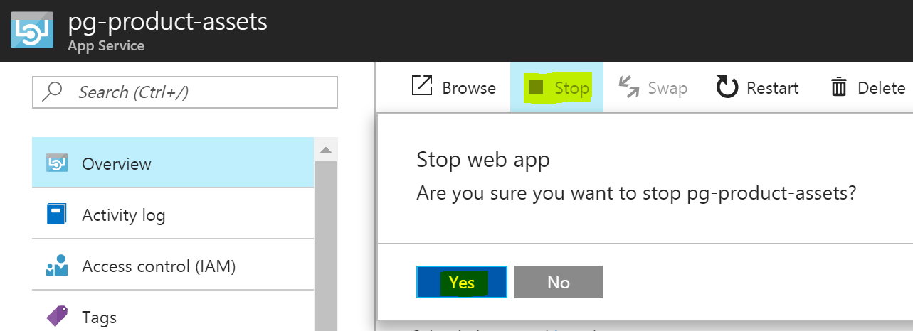

1. Access the Product Assets service (<https://pgecommerce.azure-api.net/dam/assets>) and notice that it throws an error now. Likewise access the aggregated Products service (<https://pgecommerce.azure-api.net/products/47400656109>) and notice that it throws an error as well, even though the remaining 2 services are working fine.
2. Go to policy editor for **Product Assets** service – not at an individual operation level, but at an API level.

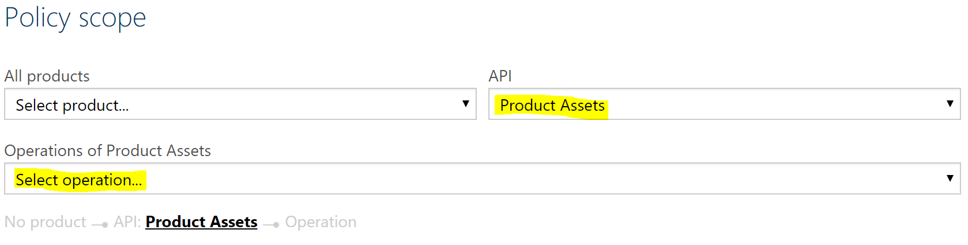

1. Add error handling policies to the outbound section of the API; configure values as shown below and save the configuration.

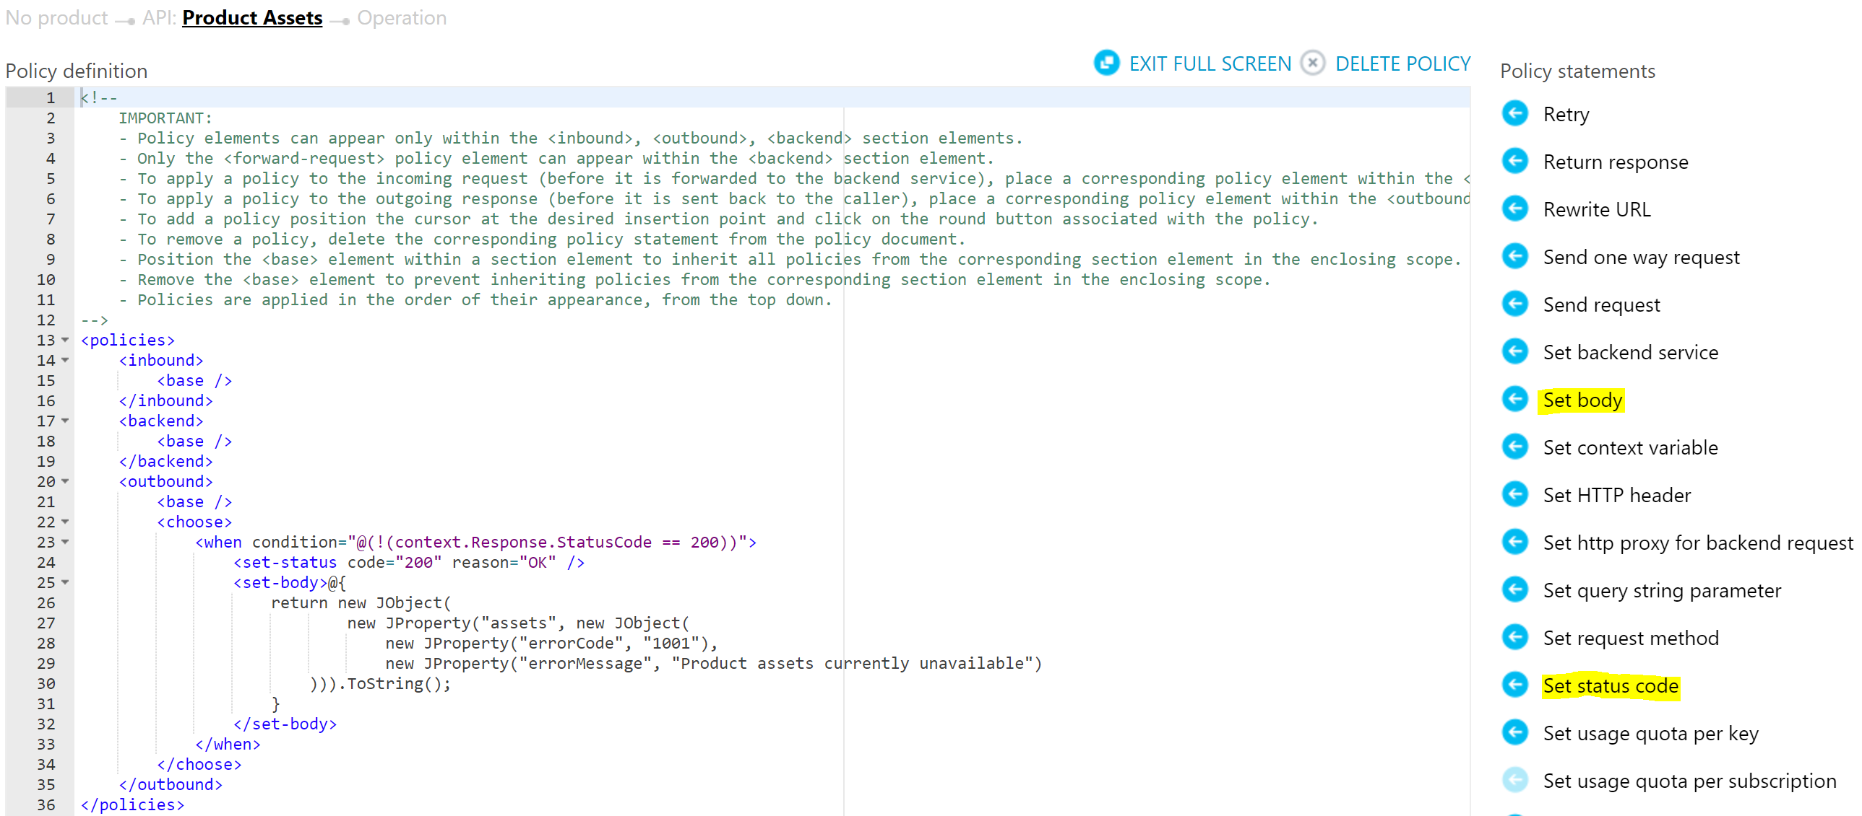

Alternatively, replace the policy definition with the content from attached file.



1. Look at some of the key service policies being used here:

|  |  |
| --- | --- |
| Policy Name | Used for |
| when condition | * To apply the error handling policy only when the backend service return a HTTP status code that is not 200 (OK) |
| set-status | * To return a 200 OK status code instead of 5xx or 4xx error code |
| set-body | * To construct the error JSON object and return as response |

1. Access the Product Assets service (<https://pgecommerce.azure-api.net/dam/assets>) and the aggregated Products service (<https://pgecommerce.azure-api.net/products/47400656109>) once again. Notice that it throws a friendly error JSON result.

# Error Handling – Approach 2

1. Access the Products service with an invalid GTIN – say <https://pgecommerce.azure-api.net/products/1234.> Note that it throws a 500 / internal server error, as the backend services have not been designed to handle this error condition.
2. Go to policy editor for **getProduct** operation of the **Product Assets** service.
3. Add error handling policy code to the API as shown below.

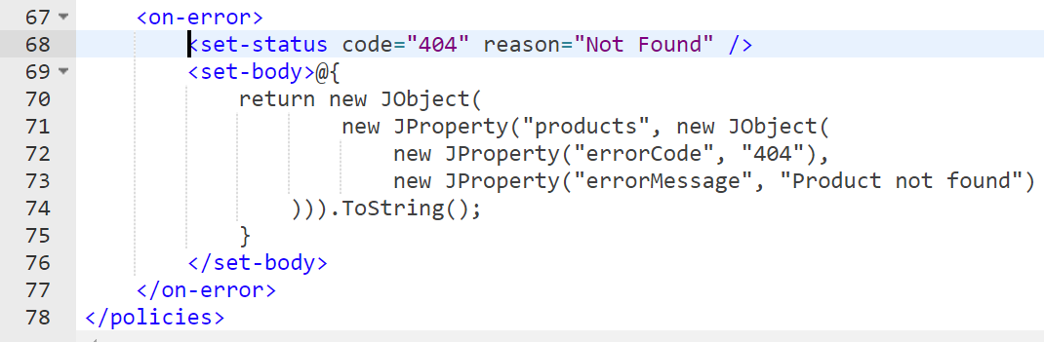

Alternatively, copy the code from attached file and add it to the end of the existing policy (before </policies> closing tag) – DO NOT replace.



1. Access the Products service once again with an invalid GTIN and note that it throws a 404 / Not Found error with a friendly error JSON result.
2. **Ensure to restart the Product Assets API app for the remaining hands-on exercises.**

# References

* Error handling – <https://docs.microsoft.com/en-us/azure/api-management/api-management-error-handling-policies>
* Changing HTTP status code – <https://docs.microsoft.com/en-us/azure/api-management/api-management-advanced-policies#SetStatus>
* Retry policy – <https://docs.microsoft.com/en-us/azure/api-management/api-management-advanced-policies#Retry>